Christian Assembly Newsletter September 2018

# **The Fear of God**

# -Sharing by Sis Jeanette Chia

Why do we need to fear God? Not the trembling frightening type of fear; but the awesome, sacred fear of a Mighty, All powerful God. A God to be revered and worshipped. The Bible tells us “But there is forgiveness with Thee, that Thou mayest be feared.” Psalm 130.4. Who can forgive sins but God the Almighty One! He has power over sin, Satan, death and hell. The psalmist tells us: “He holds the whole world in His hands. He hangs the earth on nothing.” The Lord reigns supreme over all.

Fear the Lord and turn away from evil (Proverbs 3:7)

In God’s sight, there can be no sin. Nothing evil shall enter heaven. “The Lord loves those who hate evil.” Psalm 97:10. Nothing dirty or unclean can enter heaven. He is of purer eyes than to behold evil. “Behold I make all things new.” Revelation 21:5. In the new Jerusalem – new heaven and new earth – all things shall be clean and righteous. “The fear of the Lord is the hatred of evil.” Proverbs 8:13. “The fear of the Lord is clean, enduring forever.” Psalm 19:9. The Lord is a stronghold to those whose way is upright. For a man’s ways are before the eyes of the Lord. “He watches all his ways.” Proverbs 5:21. “God incarnate is the end of fear” -F.B.Meyer. Blessed is the man who fears the Lord always. Fear can paralyse us, but faith propels us to follow God. When fear overtakes us, flee to God who is our refuge and our strength. There is no fear in God. A faithful man abounds in blessings.

The fear of the Lord is a Fountain of Life (Proverbs 14:27)

A fountain is where the water flows endlessly. God is the fountain of life. It endures forever. “The fear of the Lord prolongs life.” Proverbs 10:27. The 5th commandment exhorts us “to honour your father and mother that your days may be long”. Exodus 20:12. Your parents, who brought you up in the world, cared for you and worked hard to educate you and feed you, shall not be neglected. When you grow up and start working, then it is your turn to care for them and to honour them in their old age. It is the Lord’s command and we need to obey the Lord. “The commandment of the Lord is pure, enlightening the eyes.” Psalm 19:8b.

“In the fear of the Lord, one has strong confidence.” Proverbs 14:26. “The Lord takes pleasure in those who fear Him.” Psalm 147:11. “The fear of the Lord leads to life and he who has it rests satisfied, he will not be visited by harm.” Proverbs 19:23. There is no fear to them who trust the Lord because they exercise faith and the Lord keeps them.

The fear of the Lord is the beginning of wisdom (Proverbs 1:7)

James 1:5 exhorts us “if any man lacks wisdom let him ask of God who gives to all men liberally and upbraideth not and it shall be given to him.” But you must ask in faith without any doubts in your mind. Remember the Lord looks not on the outward, but on the inward – on your heart.

Wisdom is applied to our daily lives. It is a practical thing. In these days of evil we need the Lord’s protection, wisdom and discernment to react to the wiles of crooked people around us and those who wield lies about your loved ones who are in trouble. To take the fear out of living, put your trust in the living God. “For in Him are hid all the treasures of wisdom and knowledge.” Col 2:3. So we need caution and wisdom to live wisely in this crooked perverse world. We need to keep alert and to beware of strangers. We need the Lord’s protection in times of uncertainty. He will keep us from evil. We need to be prayerful. God is just a prayer away. He is near, He is dear, He will hear. Faith is to trust God in the dark. He has great love for His people.

To take the fear out of the living, put your trust in the living God. “The eternal God is your refuge and underneath are His everlasting arms holding you up and sustaining you.” Deuteronomy 33:27.

Conclusion

“The end of the matter: Fear God and keep His commandments; for this is the whole duty of man. For God will bring every deed into judgment whether good or bad.” Ecclesiastes 12:13.



*通知与消息*



**婚礼的祝福**

我们祝福 Bro. Daryl Pat 和 Sis. Beatrice Chua，2018年八月9号他们举行了神圣的婚礼，也愿神祝福他们今后的生活！

**<此处应包含感恩的分享>**

**感恩事项**

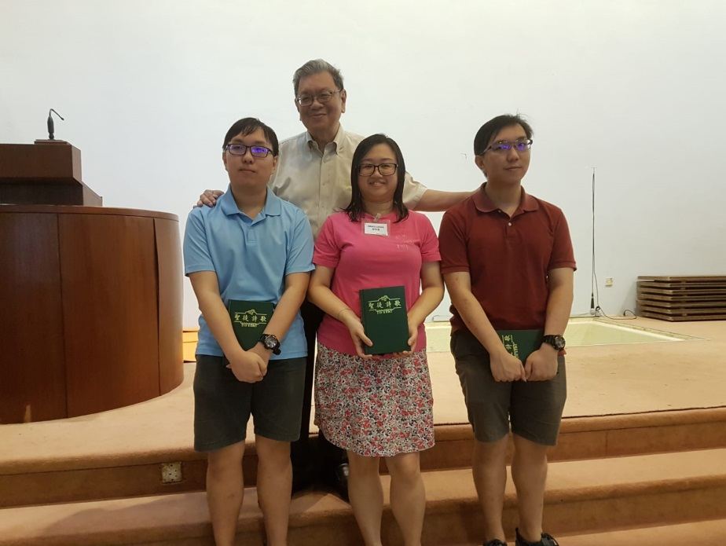感谢神，8月19号三位弟兄姐妹受洗归入基督名下- 两位弟兄 奕豪，奕伟，还有一位姊妹 a sister (name). 我们也继续在祷告当中纪念他们，求神保守看顾他们，也愿他们属灵的生命得以成长，能够为主耶稣基督的名作见证。!

j0332982

***应当一无挂虑，只要凡事藉着祷告、祈求和感谢，将你们所要的告诉神。腓立比书 4：6***

***神所赐、出人意外的平安必在基督耶稣里保守你们的心怀意念。腓立比书 4：7***

*警醒祷告*

**祷告事项**

**讲台上的侍奉**

请在祷告中纪念讲台上的服侍 :

* 求神膏抹祂仆人的口，使他们可以将神带有恩膏有能力的话语传递出来
* 愿讲员和翻译人员可以全心依靠神，带着爱和谦卑传递神的话语
* 愿会众都能够预备好自己的心，打开自己的耳朵，有顺服的灵去聆听神的话，并且遵守神的道
* 愿生灵对我们每一个人的心说话，光照我们，更新我们的观念，改变我们使我们更像基督

为以下的讲员祷告：

|  |  |  |  |
| --- | --- | --- | --- |
| 日期 | **讲员** | | |
| **威基台** | **泛亚** | **福音聚会** |
| 2018/09/02 | Tan Yark Khwee | 洪伟伦 | 林文中 |
| 2018/09/09 | Loh Sit Ming | Teo Ching Han |  |
| 2018/09/16 | Yeo Choon Guan | 孙福兴 |  |
| 2018/09/23 | Chua Meng Khiang | Tan Yark Khwee |  |
| 2018/09/30 | Tan Boon Guan | 杨恩华 |  |

**主日学**

新的一年就要来临，我们一起为以下事项祷告：

* 主日学主管和老师能够同心合意寻求神的心意，等候在神面前，求神能够带领主日学的服侍
* 主日学老师能够完全依靠神并且忠心地传递神的话
* 主日学的学生能够渴慕学习神的话语, 能够亲近神并与神建立亲密的关系
* 学生的家长/监护人能够对主日学校有信心，愿意让孩子参加主日学

**长老与执事们**

长老和执事们会定期开会讨论教会的事项，我们为他们祷告:

* 他们能够有基督的心思和意念
* 使他们能够带着爱心并且在基督里有合一的灵
* 明白神对教会的旨意，来指导教会的方向
* 做出讨神喜悦的决定

**大使命**

请在祷告中纪念在即将在马六甲和柬埔寨的宣教事工。

**请在祷告中纪念以下的弟兄姐妹，包括那些身体不适的、年老的和那些无法参加教会生活的：**

* 一大群来自基督徒聚会所两所教会（威基台和泛亚）的兄弟姐妹将前往中国，请为他们祷告，求神保护他们，使他们旅途一切顺利，也使他们在主里有美好的友谊。
* **孙耀光弟兄**
* **孙福兴弟兄**
* **惠溢姊妹**
* **Sis Ling Kam** 即将接受化疗
* **Sis Irene Leong** 摔伤了手腕和臀部。
* **Bro. Keen Mun’s mother**
* **Bro. Tan Song Seng** 刚刚做了脊柱外科手术，希望他能够早日康复
* **张秀英姊妹**已经转移到狮子乐龄之家，这是一家在碧山的老人之家，她在那里准备接受理疗。
* **Sis Christina** 呼吸困难，右心脏衰竭
* **Mrs Wang Li Zhong and Mrs Lee 走路不便**
* **其他神按名几年的弟兄姐妹**

愿神赐下祂的同在和恩典安慰他们，坚固他们

**教会侍奉**

教会的各项侍奉需要你的祷告和参与，这将会给基督的身体带来很大的鼓励。

“**你们就是基督的身体，并且各自作肢体**.” **哥林多前书** 12：27

##### **信息月刊** … 分享见证、图片和文章造就弟兄姐妹。

* **载送服侍** … 为那些会驾车的兄弟姐妹们祈祷，让他们志愿成为福音车的司机，那些有车的弟兄姊妹能够为那些有需要的人提供帮助，特别是老人和住在不同地区的年纪小的孩子。

**请注意:**

由于每个月的“信息”将准时在每个月的第一个主日出版，为了翻译和“信息”印刊的缘故，每个月的祷告事项将收集至每个月的第三个星期三。

每个月的第四个星期三所报告的祷告事项，除非下一期的《信息》出版时还有效，否则将不会被刊登。我们感谢教会弟兄姊妹的谅解。